Success stories (total 3)

- Case Study no. : 01

- Title of story: Integrated Jalkund

- Location: DUMERDIHA

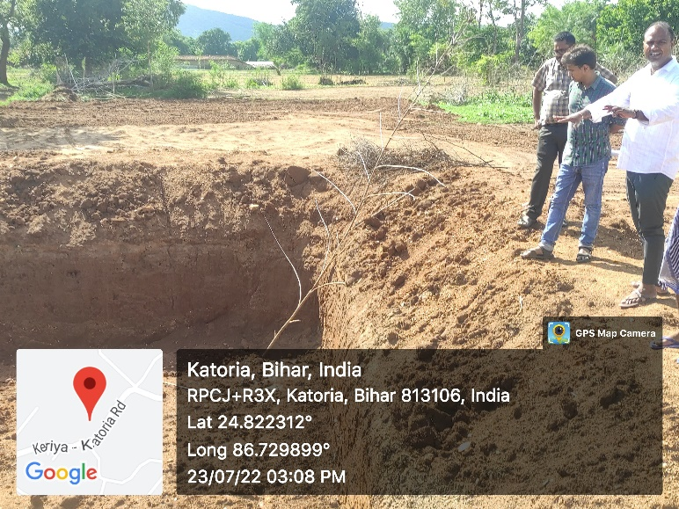
- Project Facilitation Agency: MUKTI NIKETAN BHAGALPUR

- Problem Description: Irrigation remains a major problem for the farmers, even today farmers mainly depend on rain water and due to this they are not able to cultivate vegetable and fish farming.

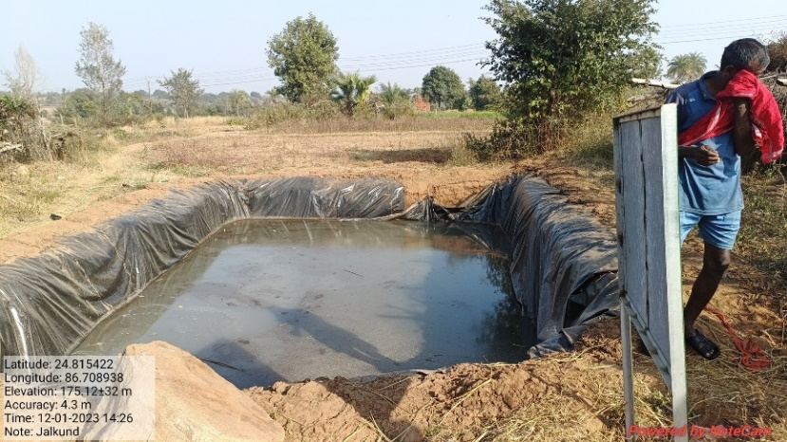
- Intervention: Excavation of the Jalkund on selected site is to be completed before on set at monsoon. The bed and sides of the Jalkund are to be levelled by removing rocks. The inner walls including bottom of the Jalkund are to be properly smoothened by plastering with mixture at clay and cow dung in the ratio 5:1. Jalkund is needed to be covered with thatch (5-8cm thik) made of local available bamboo and grasses. Use of thatch reduce evaporation upto 80% in comparison to the control Jalkund without any cover.

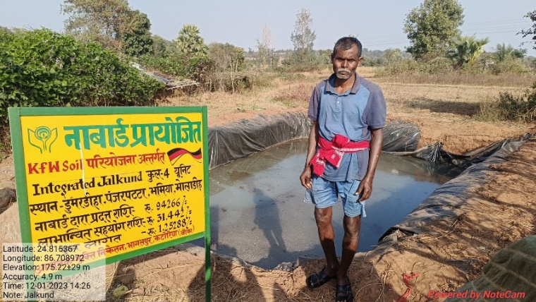
- Progress and Result : Direct rain-fall collection through water catch Jalkund can be highly beneficial to farmers for providing irrigation to cropes during moisture scarcity conditions during dry seasons. Rainfall water can be stored directly in Jalkund during the rainy season which can be utilized to proved protective irrigation to the crops for successful cultivation.

- Impact: Vasudev Das is durig vegetable farming and fish farming through Jalkund and also utilized stored water for animal husbandry activities poultry and duckery.

- Inspiration : Vasudev Das has been presented an example of farmers, how can the rain water which was being wasted, trough the Jalkund be used in irrigation, in animal husbandry and in fish farming.

Success stories-2

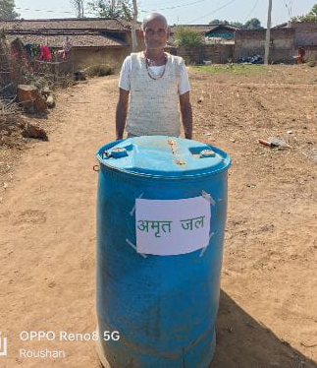
- Case Study no. : 02

- Title of story: Liquid manure & growth enzyme preparation.

- Location: Lachhanadih

- Project Facilitation Agency: MUKTI NIKETAN BHAGALPUR

- Problem Description: Farmers depends on fertilizers as per the needs of the sill chemical fertilizers, due to many reasons, are harmful for the soil. Farmers are replacing chemical fertilizers by organic fertilizers. Jivamirut/Amrutjal is the best. When farmers produced it themselves in abundances, their need is fulfilled at no cost.

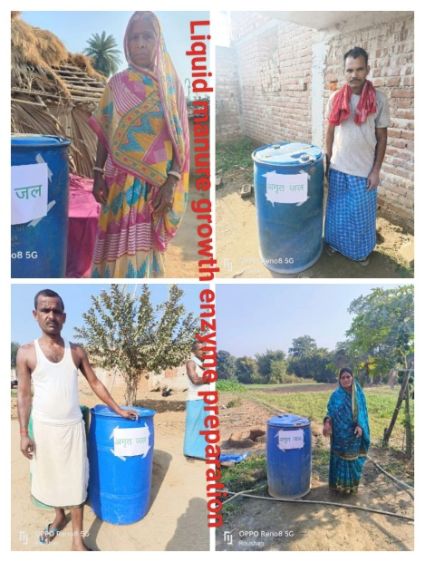
- Initiation Taken: First of all takes 1 plastic drum and mix 10ltr. cow urine, 10ltr. cow dung, 500gm. Jaggery and 100ltr. water. Keep it f 3 days and everyday stir it 3 times. On the 4th day, dilute the solution by 10 times and it is ready to use from 4th day to7th day.

- Progress and Result : Visheshwar Yadav & Nuneshwar Yadav has been a progressive farmers in Lachhanadih. Both are hard working farmers. They do vegetable cultivation in sufficient quantity in all seasons. Jeevamrut/ Amrutjal has been used in kitchen garden. Due to this. There is very good growth in his Plants and also the soil moisture is maintained.

- Impact:
- By addingJeevamrut to the soil the plans absorbs the nutrients from thesoil very fast and easily.
- By putting Jeevamrut in the soil, the number of earthworms increases.
- Using Jeevamrut makes the soil fertile and increases its fertility.
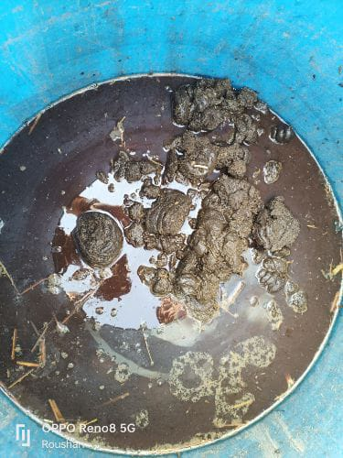
- By using Jeevamrut in farming, fruits, vegetables and grains become very mature.
- Jeevamrut also increases disease resistance in plants and crops.

- Inspiration : This is a good example that by using Jeevamrut, we can reduce the cost in agriculture and promote organic farming; so that the fertility of the field will be maintained and moisture in the soil will also be maintained.

Success stories-3

- Case Study no. : 03

- Title of story: Demonstration Model of Shadras seeds manuring techniques.

- Location: LARAIYACHATTI

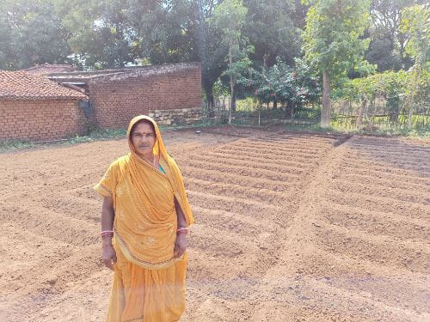
- Project Facilitation Agency: MUKTI NIKETAN BHAGALPUR

- Problem Description: Farmers can not buy green vegetables and their food content is not balance. This year there has been complete failure of monsoon. The farmer has gone to hand to mouth.

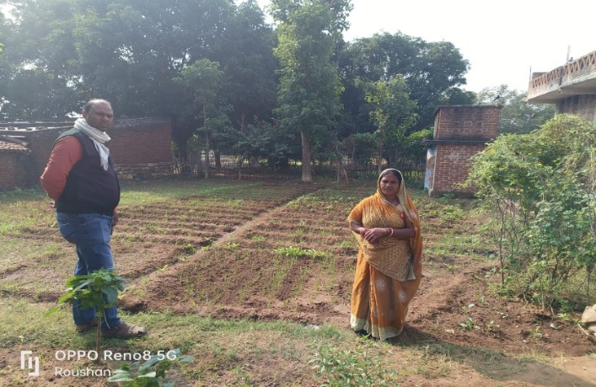
- Initiation Taken: Under model of shadras seeds technique Ajay Yadav was selected. He promised to follow all norms. He bounded the area, ploughed properly, removed weeds, put compost in the soil and sowed the seeds. Proper care was given on dressing and irrigation. Plants grew well flowering and fruiting resulted in time. Green manuring with shadras seeds (Seeds of six taste- sweet, sour, salty, Bitter, pungent and astringent) ensures balanced nutrient profile of soil.

- Progress and Result : Fruiting was very nice, Everywhere in land around the villages there was shortage of green vegetable consumes like local vegetables. Ajay Yadav was encouraged. H did not loose patience. He started selling vegetables. Quality was very good. He spent his bad day and he is happy to enjoy the fruit of labour.

- Impact:
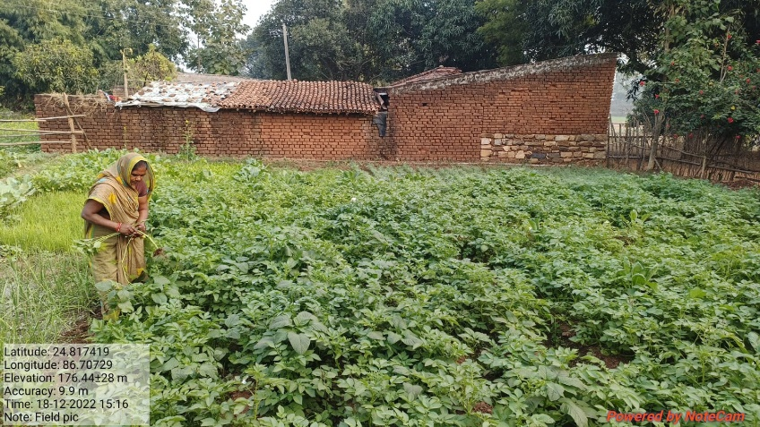
- Adds nutrients and organic matter to the soil.
- Improves physical , chemical and biological properties of the soil.
- The income of Ajay Yadav started increasing
- Seeing Ajay Yadav, the farmers in the villages also started adopting this technique.

- Inspiration : Land gives $≠$ Life and livelihood.
Labour never goes in vain.

